**IOT Device**

IOT devices are the connecting fabric between devices. Connecting up all these different objects and adding sensors to them adds a level of digital intelligence to devices that would be otherwise dumb, enabling them to communicate real-time data without involving a human being. The Internet of Things is making the fabric of the world around us more smarter and more responsive, merging the digital and physical universes.

**Smart doorbell :-**

A smart doorbell is an internet-connected doorbell that notifies the smartphone or other electronic device of the home owner when a visitor arrives at the door. It activates when the visitor presses the button of the doorbell, or alternatively, when the doorbell senses a visitor with its built-in motion sensors. The smart doorbell lets the home owner use a smartphone app to watch and talk with the visitor by using the doorbell's built-in high-definition infrared camera and microphone. They can be either battery operated or wired. Some smart doorbells also allow the user to open the door remotely using a smart lock.

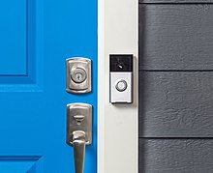

Today, the 2nd generation of smart home devices is coming. The main difference between the 1st and the 2nd generation is its Edge Inference capability. Meaning running AI algorithms directly on the device and not in the cloud. It opens up new possibilities as edge AI lowers the detection time as well as the cost (no more expensive cloud bills). The challenge is how to deploy AI Models to the edge, securely, and at scale on various types of hardware.

